**Setting up alert for client and server errors in Dashboard**

**Step 1**: Created a contact with both teams and email integragration

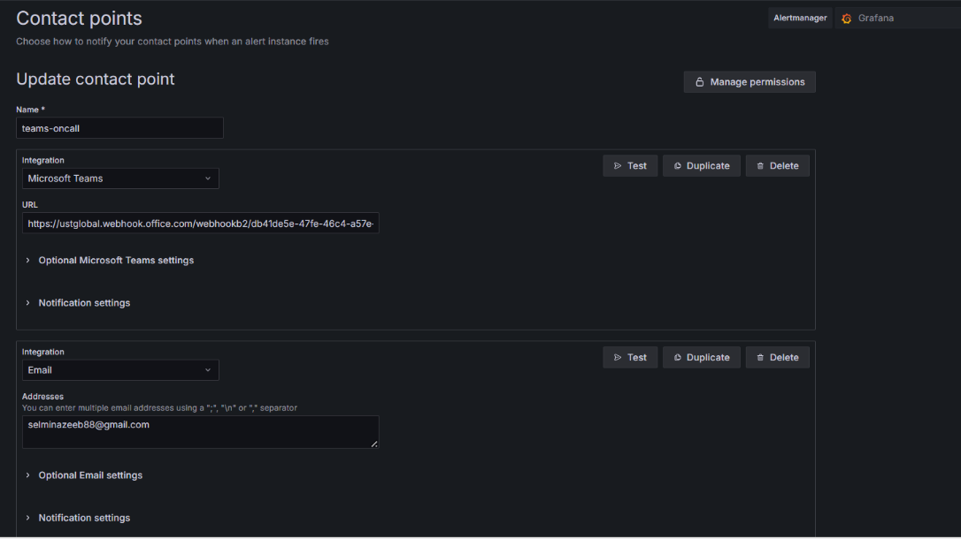

**Step 2:** Created alert rule for 4xx errors with threshold

**Step 3:** Created alert rule for 5xx errors with threshold

* Select datasource infinity
* Add csv data
* Select needed columns fron data
* Add threshold
* Add evaluation group
* Select folder
* Add summary and description message

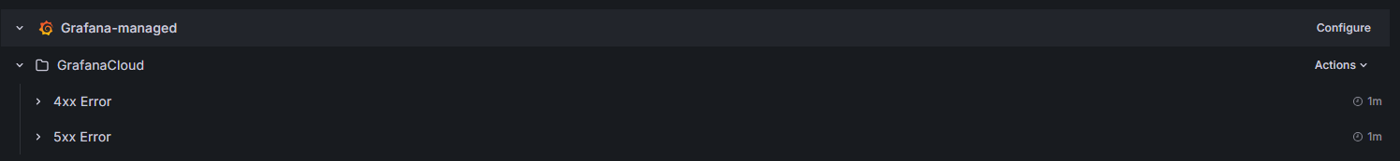

**Step 4:** Configured the notification message

Summary - 🚨 {{ $labels.service }} is throwing {{ $labels.error_code }} errors

Description –

Service: {{ $labels.service }}

Error Code: {{ $labels.error_code }}

Message: {{ $labels.message }}

Error Count: {{ $values.A }}

**Output:** Alert notification for 4xx error in teams and email  
with service, error code, count and message

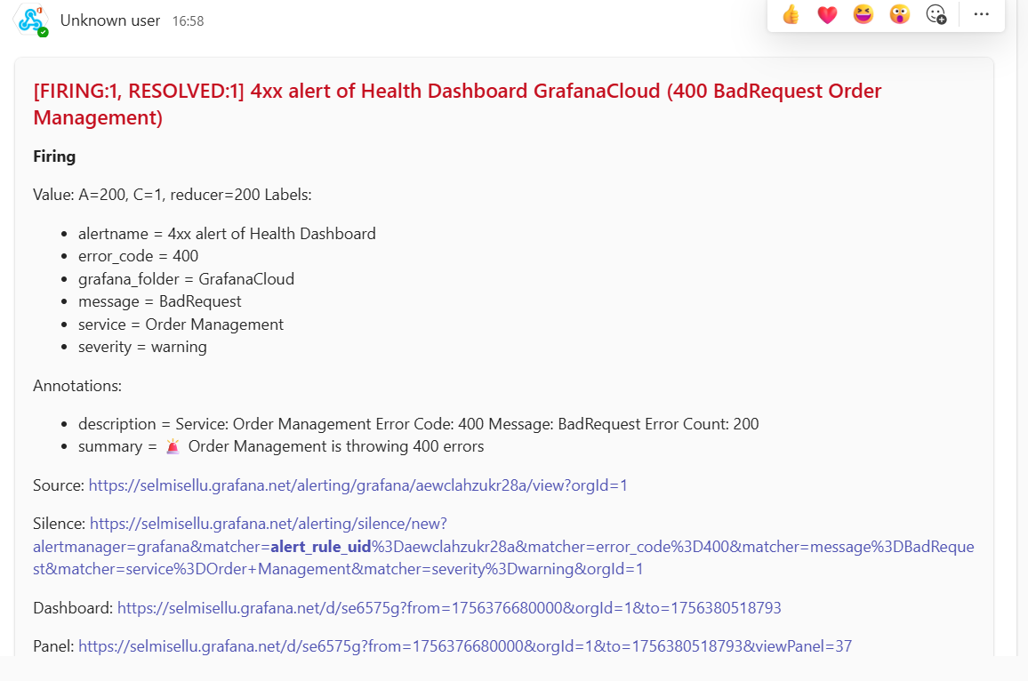

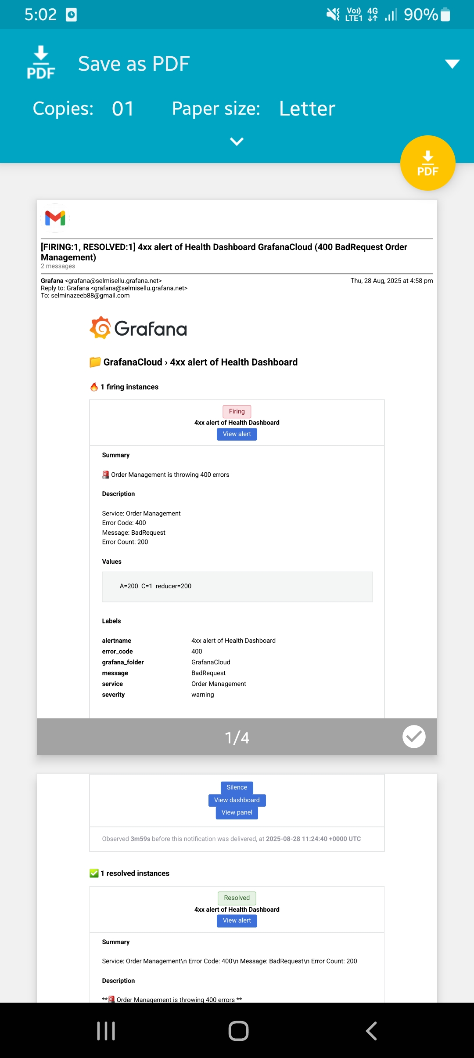

**Output:** Alert notification for 5xx error in teams and email  
with service, error code, count and message



